**Battle of Neighborhood**

**Brooklyn, NY**

**Introduction**

Setting up a new business is always challenging ask, especially when the area where we plan to setup a new venture is new and unexplored. One of such business is opening a new restaurant where understanding the demographic of the area, population density, current competition, feasibility and demand analysis is very important. Above all choosing the right location is of prime importance so below mentioned key points should be analyzed before finalizing the restaurant's location.

A location with already existing restaurants with good turnover of customers like malls, shopping areas and movie theaters can be a probable location.

A location where there is room and opportunity to explore and less competition

A location which is close to prominent neighborhoods with a good influx of customers

Goal of this project is to explore a different neighborhood of Brooklyn, NY by analyzing population density and number of existing restaurants among the neighborhoods to suggest most suitable good location to open a new Asian restaurant. Additionally this project will serve as a guide for any newcomer in Brooklyn, NY and assist in exploring the neighborhood as a whole.

**Objective/Purpose**

The objective of this project is to explore and analyze different neighborhoods of Brooklyn to understand the Borough as a whole and also identify a suitable location to open a new Asian restaurant by:

1. Locating a neighborhood that has more number of restaurants as it implies that there is a good demand of them.
2. Finding a location where there are no or very few Asian restaurants that ensures that there is very little competition for the new restaurant.

**Data**

Dataset to analyze the neighborhood is extracted from a JSON file <https://ibm.box.com/shared/static/fbpwbovar7lf8p5sgddm06cgipa2rxpe.json> from which consist of data for all neighborhoods within New York. For this project the focus was on extracting the data for the borough Brooklyn. Python Pandas library are used to achieve this.

Once the data is extracted, leveraging Foursquare API <https://developer.foursquare.com/> to find the venues to open Asian restaurant within 500 meters of the neighborhood in Brooklyn

Population density distribution among the neighborhood is fetched through web-scrapping from <https://www.worldatlas.com/articles/brooklyn-neighborhoods-by-population.html>

**Methodology**

* Data of New York city is read from a json file and is cleaned to retain only the required details of the Brooklyn borough.
* Neighborhoods are visualized using Folium
* Neighborhoods are explored using Foursquare APIs to find most common categories of venues.
* K-means clustering algorithm is used to group neighborhoods into different clusters.
* Folium map is used to visualize neighborhoods and their emerging clusters.
* The venues in the neighborhoods are filtered to find total restaurants and Asian restaurants.
* The neighborhoods are studied to find top most venues in them.

**Libraries, Packages and APIs used**

* Pandas
* Geopy
* Json
* NumPy
* Folium
* Requests
* Matplotlib
* Scikit-learn
* Four Square API
* Sklearn

**Results**

After the filtering of data for the Brooklyn borough 70 neighborhoods were identified. In these neighborhoods there are total 664 restaurants which shows that there is a great demand of restaurants in Brooklyn. Out of 664 restaurants only 16 offer Asian cuisine.

The neighborhoods with the maximum number of restaurants are depicted below

|  |  |  |  |
| --- | --- | --- | --- |
|  | **Neighborhood** | **Restaurant count** | **Asian Restaurant count** |
| **14** | Clinton Hill | 35 | 0 |
| **55** | South Side | 34 | 2 |
| **1** | Bay Ridge | 32 | 1 |
| **15** | Cobble Hill | 30 | 0 |
| **48** | Prospect Heights | 27 | 0 |
| **43** | North Side | 25 | 1 |
| **27** | Fort Greene | 25 | 0 |
| **8** | Brooklyn Heights | 23 | 2 |
| **12** | Carroll Gardens | 23 | 0 |
| **34** | Greenpoint | 22 | 0 |
| **47** | Park Slope | 21 | 0 |
| **19** | Downtown | 21 | 2 |
| **10** | Bushwick | 21 | 0 |
| **0** | Bath Beach | 18 | 1 |
| **4** | Boerum Hill | 16 | 0 |
| **20** | Dumbo | 15 | 0 |
| **32** | Gowanus | 14 | 0 |
| **6** | Brighton Beach | 14 | 0 |
| **28** | Fort Hamilton | 13 | 1 |
| **23** | East Williamsburg | 12 | 0 |
| **41** | Mill Basin | 12 | 0 |
| **49** | Prospect Lefferts Gardens | 12 | 0 |
| **29** | Fulton Ferry | 12 | 0 |
| **50** | Prospect Park South | 12 | 0 |
| **3** | Bensonhurst | 11 | 1 |
| **36** | Homecrest | 10 | 1 |
| **17** | Cypress Hills | 10 | 0 |
| **18** | Ditmas Park | 9 | 0 |
| **37** | Kensington | 8 | 0 |
| **51** | Red Hook | 8 | 0 |
| **54** | Sheepshead Bay | 8 | 0 |
| **57** | Sunset Park | 7 | 0 |
| **25** | Flatbush | 7 | 0 |
| **5** | Borough Park | 6 | 0 |
| **60** | Williamsburg | 6 | 0 |
| **61** | Windsor Terrace | 6 | 0 |
| **52** | Remsen Village | 6 | 0 |
| **13** | City Line | 5 | 0 |
| **26** | Flatlands | 5 | 0 |
| **9** | Brownsville | 5 | 0 |
| **53** | Rugby | 4 | 0 |
| **33** | Gravesend | 4 | 0 |
| **11** | Canarsie | 4 | 1 |
| **24** | Erasmus | 4 | 0 |
| **30** | Georgetown | 4 | 0 |
| **56** | Starrett City | 3 | 0 |
| **62** | Wingate | 3 | 0 |
| **44** | Ocean Hill | 3 | 0 |
| **39** | Manhattan Terrace | 3 | 0 |
| **2** | Bedford Stuyvesant | 3 | 0 |
| **46** | Paerdegat Basin | 2 | 1 |
| **45** | Ocean Parkway | 2 | 0 |
| **42** | New Lots | 2 | 1 |
| **40** | Midwood | 2 | 0 |
| **35** | Highland Park | 2 | 0 |
| **21** | East Flatbush | 2 | 0 |
| **16** | Coney Island | 2 | 0 |
| **58** | Vinegar Hill | 2 | 0 |
| **7** | Broadway Junction | 2 | 0 |
| **31** | Gerritsen Beach | 2 | 0 |
| **38** | Madison | 1 | 0 |
| **22** | East New York | 1 | 0 |
| **59** | Weeksville | 1 | 0 |

Below study of population density distribution among these neighborhoods helped in further analysis of above neighborhoods.

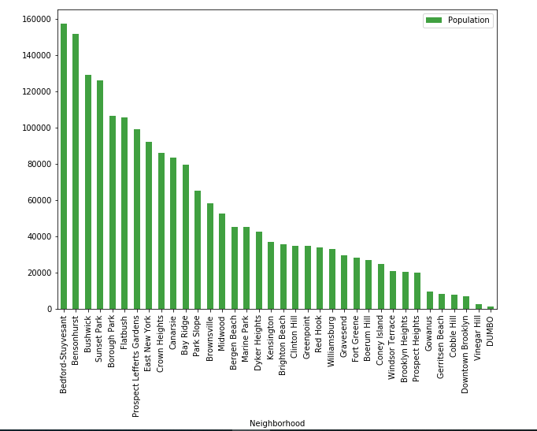

**Discussion**

The top four neighborhoods with the majority of restaurants are Clinton Hill, South Side, Bay Ridge and Cobble Hill are well suited for opening a new restaurant moreover they belong to the same cluster and this cluster as whole has good number of restaurants. Bay Ridge is also having a good population density. For these neighborhoods out of there the top 10 most common venues majorities are restaurants.

**Conclusion**

### This analysis concludes that Clinton Hill is the best option among all the neighborhoods to open a new Asian restaurant followed by Bay Ridge and Cobble Hill. As these neighborhoods have the greatest number of restaurants in Brooklyn so opening a new restaurant with Asian cuisine will provide one more option to the customers.

### Even though South Side ranks second in the list but as it already has two Asian restaurants so opening a new restaurant here will face more competition.

### Population distribution among these neighborhoods suggests that after Clinton Hill, Bay Ridge is a better option rather than Cobble Hill as it is more densely populated.